Supplementary data
Dependent variable | Generalist abundance |  |  |  | Specialist abundance |  |  |  | Specialist-to-generalist ratio
 | Estimate | SD | t | p | Estimate | SD | t | p | Estimate | SD | t | p
Intercept | 24106.8 | 10799 | 2.23 | <0.05 | -2055.21 | 2574.73 | -0.80 | 0.43 | -3.32 | 1.60 | -2.08 | <0.05
NDVI | 4107.6 | 5117.5 | 0.80 | 0.42 | 2271.18 | 1220.13 | 1.86 | 0.07 | 1.42 | 0.76 | 1.88 | 0.06
Temperature | -426.3 | 435.4 | -0.98 | 0.33 | 122.35 | 103.81 | 1.18 | 0.24 | 0.13 | 0.06 | 2.00 | <0.05
ECO5.1.4 | -17361.7 | 7803.5 | -2.23 | <0.05 | 771.58 | 1860.53 | 0.42 | 0.68 | 1.87 | 1.16 | 1.62 | 0.11
ECO5.3.1 | -19392.5 | 8139.5 | -2.38 | <0.05 | 1115.72 | 1940.64 | 0.58 | 0.57 | 2.32 | 1.20 | 1.93 | 0.06
ECO8.1.7 | -16668.7 | 7106.3 | -2.35 | <0.05 | 1016.74 | 1694.30 | 0.60 | 0.55 | 1.92 | 1.05 | 1.83 | 0.07
ECO8.5.1 | -9188.7 | 4425.6 | -2.08 | <0.05 | 546.26 | 1055.25 | 0.52 | 0.61 | 1.06 | 0.66 | 1.62 | 0.11
NDVI:Temperature | -640.8 | 353 | -1.82 | 0.07 | -135.73 | 84.15 | -1.61 | 0.11 | -0.06 | 0.05 | -1.11 | 0.27

Table S1. Summary of the three linear model explaining generalist abundance, specialist abundance, and specialist-to-generalist ratio.

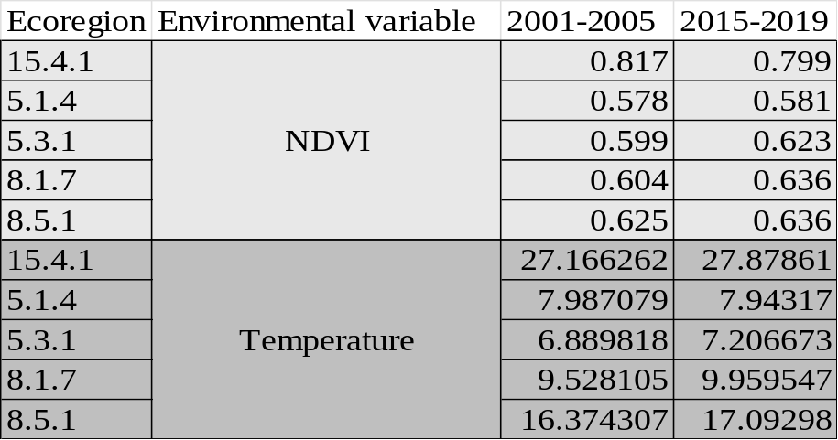
Table S2. The mean NDVI and temperature recorded during each period.

